7. Invalidate Checks

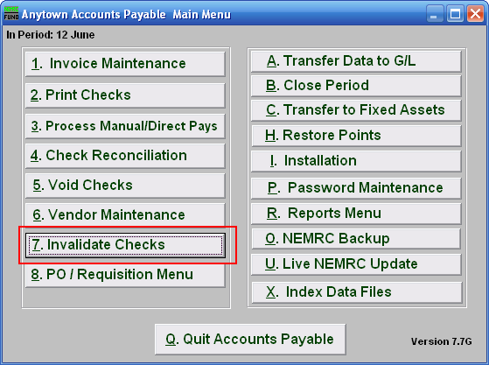
Click on “7. Invalidate Checks” from the Main Menu and the following window will appear:

Invalidate Checks

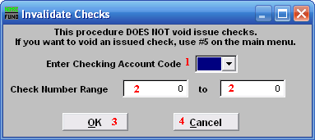
- Enter Checking Account Code: Enter the Checking Account Code or use the drop down arrow to select from there.

- Check Number Range: Enter the Check Number Range you wish to invalidate.

- OK: Click “OK” to accept and return to the Main Menu.

- Cancel: Click “Cancel” to cancel and return to the Main Menu.

The purpose of this function is to create a record of checks that can be reported as voided check when an event has happened to render the check unusable.

